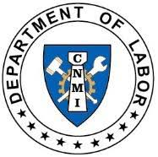
Commonwealth of the Northern Mariana Islands
Department of Labor
Office of the Secretary
1356 Mednilla Avenue | Capitol Hill
P.O. Box 10007 | Saipan, MP 96950
Phone: (670) 664-3196
Web: www.marianaslabor.net

Instructions for Completing the Total Workforce Listing (TWL)
- Forms

  - Available online at www.marianaslabor.net
  - Click on “Resources and Publications”, then “Forms and Publications”, then
“Total Workforce Listing” for a copy (see below).

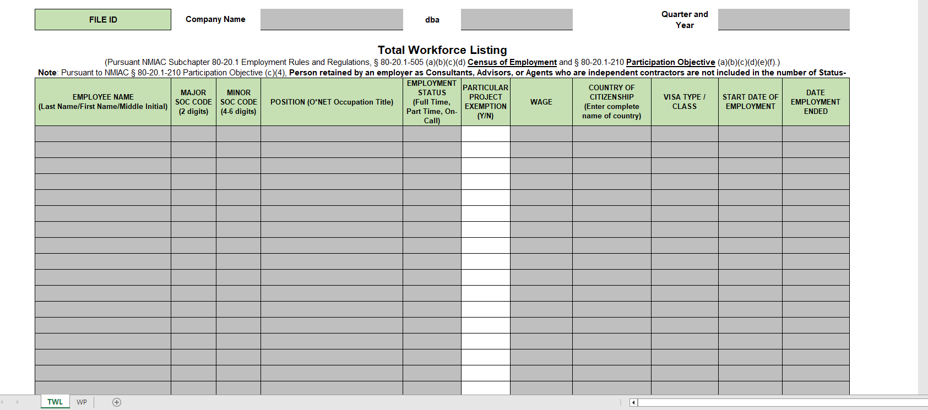

- Deadlines

  - First quarter (January, February, & March) due April 30
  - Second quarter (April, May, & June) due July 31
  - Third quarter (July, August, & September) due October 31
  - Fourth quarter (October, November, & December) due January 31 – of the following year

- Document Submission

  - Send completed Excel form(s) to documents@marianaslabor.net.

FILE ID SECTION: Complete the “File ID” section located at the top of the TWL form. Enter company name/dba and the quarter and year of submission.

Enter the employee’s name beginning with last name, first name, then middle initial.
To avoid errors, ensure that all employee names on the TWL form mirror employee names on documents prepared for income tax filing.
Part 1
EMPLOYEE NAME

From the drop-down list, select the employee’s 2-digit major SOC code.
1. To verify the occupation’s Major SOC, go to https://www.onetonline.org.

2. On the top right-hand corner, type in the specific occupation or position in the occupational keyword search box (ex: “electrician”). Click on “Go”.

3. A list of occupations will show on the next page.

4. Locate the specific occupation and take note of the numbers adjacent to the occupation/position. Using the example occupation above (electrician), you will see a series of numbers displayed: “47-2111.00”. The first two digits “47” represent the occupation’s major SOC.

Part 2

MAJOR SOC CODE

Part 3

MINOR SOC CODE
Enter the employee’s minor SOC code.
1. To obtain the occupation’s Minor SOC, go to https://www.onetonline.org.
2. On the top right-hand corner, type in the specific occupation or position in the occupational keyword search box (ex: “electrician”). Click “Go”.

3. A list of occupations will show on the next page. Locate the specific occupation and take note of the numbers adjacent to the occupation/position. Using the example occupation above (electrician), you will see a series of numbers displayed: “47-2111.00”. The four digits “2111” represent the occupation’s minor SOC.

4. After obtaining the minor SOC code, you may enter those numbers into the TWL.

Enter the employee’s job position according to O*NET.
The job position entered must correspond to the major and minor SOC code. Be as specific as possible - according to ONET classifications. Visit the ONET online website listed in Parts 2 & 3, or contact the Department for assistance.
Part 4
POSITION (O*NET Occupation Title)

From the drop-down menu, select the employee’s employment status.

The only available options are “Full Time” and “Part Time”. Workers who are considered seasonal, at-will, temporary, or interns will be considered as Part Time employees.
Part 5
EMPLOYMENT STATUS

Part 6
PARTICULAR PROJECT EXEMPTION

For Official Use Only. Do not complete this part.

Enter the employee’s wages/salary.
Here are some acceptable forms of wages/salary:
    - $7.25 hr.
    - $500 bi-weekly
    - $1,000 monthly
    - $40,000 per annum
Part 7

WAGE

From the drop-down menu, select the employee’s country of citizenship.

“U.S.” = employees originating from U.S., CNMI, Guam, American Samoa, Puerto Rico and U.S. Virgin Islands

“FSM” = employees originating from Chuuk, Kosrae, Pohnpei and Yap

“FAS” = employees originating from Marshall Islands and Palau

Part 8

COUNTRY OF CITIZENSHIP

From the drop-down menu, select the employee’s visa type or class.

Select “US” for U.S. citizen workers (ex: U.S. passport holders).
Select “LPR” for a worker with a Green Card.
Select “FSM” for a worker from Chuuk, Kosrae, Pohnpei and Yap.
Select “FAS” for a worker from Marshall Islands and Palau.
Select “EAD” for a worker with CNMI Long Term Resident.

Part 9

VISA TYPE/CLASS

Enter the employee’s date of employment.
IMPORTANT: Please enter as MM/DD/YYYY.
Part 10
START DATE OF EMPLOYMENT

Enter the employee’s last date of employment. Some examples include official resignation dates, termination dates, and/or dates of separation from the company.
IMPORTANT: Please enter as MM/DD/YYYY.

Part 11
DATE EMPLOYMENT ENDED

No action required. This section is auto-populated once Parts 1-11 are completed.
For accuracy, ensure that all workers (U.S. and Non-U.S.) correspond accurately to their employment statuses, country of citizenship and visa type/class.

- U.S. Workers = U.S., LPR, FSM, and FAS Workers.
- All other workers count as non-U.S. Workers.
- Employment status = Full Time or Part Time only.
Part 12

WORKFORCE TALLY

CERTIFICATION SECTION

IMPORTANT: Completing the Certification section is equivalent to submitting an official document to the Department of Labor. As much as possible, ensure that the preparer/submitter: (1) validates all the information entered in the document and (2) endorses the document prior to submission. Failure to endorse the document will result in several actions:

- The TWL will be rejected by the Department;
- Considered as a “non-submission”, and therefore non-compliant;
- Flagged for incompletion, causing processing delays; and
- Delays in other DOL requests (e.g., JVA certification, good-standing, etc.).

To complete the Certification section:

1. Enter the preparer’s “Name and Position”.
2. Enter the day, month, and year of submission.
3. Enter the preparer/submitter’s name and date.

Contact Information:

Commonwealth of the Northern Mariana Islands
Department of Labor
Office of the Secretary
1356 Mednilla Avenue | Capitol Hill
P.O. Box 10007 | Saipan, MP 96950
Phone: (670) 664-3196
Web: www.marianaslabor.net Version update: September 19, 2023

