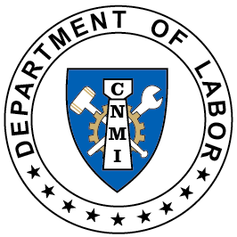
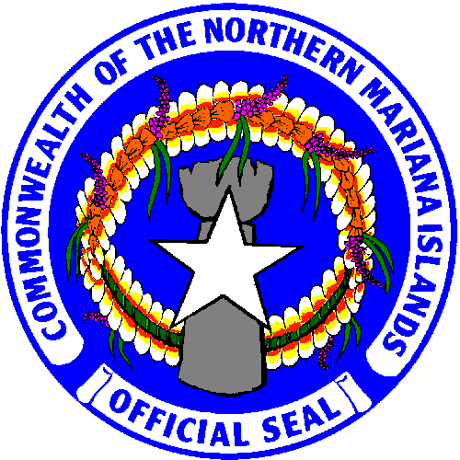
OSHA TRAINING
Commonwealth of the Northern Mariana Islands
DEPARTMENT OF LABOR
OFFICE OF THE SECRETARY
#1356 Mednilla Ave. Capitol Hill, P.O. Box 10007, Saipan MP 96950
Telephone (670) 664-3196; Facsimile: (670) 664-3197
www.marianaslabor.net

The CNMI Department of Labor, CNMI-OSHA Consultation Program in collaboration with OSHA Training Institute and Education Center at the University of California, San Diego, will be conducting FREE training on the following schedule dates and topics:

When:
February 19, 2019 – 9:00 am – 11:30 am
- Electrical/electrocution hazards during Typhoon Clean-up
Operations.
February 19, 2019 – 1:00 pm – 3:30 pm
- Fall protection during Typhoon Clean-up Operations.
February 26, 2019 – 9:00 am – 11:30 am
- Health and Hygiene during Typhoon Clean-up Operations.
February 27, 2019 – 9:00 am – 11:30 am
- Demolition Hazards during Typhoon Clean-up Operations.
WHERE: Aqua Resort Club, San Roque, Saipan

To Register or for more information, call the CNMI-OSHA Consultation Program at tel. 664-3154/55/56/57, 287-7531/33 or email:
Elaine Pangelinan Wallace Chong
elaine.pangelinan@gmail.com wchongdolosha@gmail.com

Sidney Camacho
scamachodolosha@gmail.com

The training is provided under the grant SH05076SH8 from the U.S. Department of Labor, Occupational Safety and Health Administration (OSHA). The training and the material provided during the training does not necessarily reflect the views or policies of the OSHA, nor does mention of trade names, commercial products, or organizations imply endorsement by the U.S. Government.

