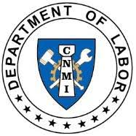
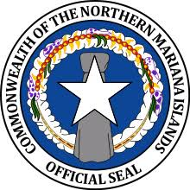
Commonwealth of the Northern Mariana Islands
Department of Labor
Office of the Secretary
1356 Mednilla Avenue | Capitol Hill
P.O. Box 10007 | Saipan, MP 96950
Phone: (670) 664-3196
Web: www.marianaslabor.net

Instructions for Completing the Workforce Plan (WP)
- Forms

  - Available online at www.marianaslabor.net
  - Click on “Resources and Publications”, then “Forms and Publications”, then
“Workforce Plan” for a copy (see below).

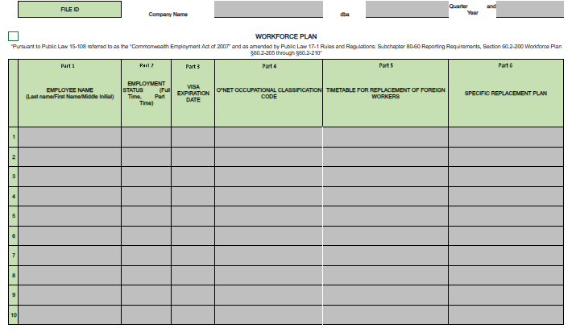

- Document Submission

  - Send completed Excel form(s) to documents@marianaslabor.net.
  - Do not convert the Excel spreadsheet to any other format (ex: PDF, Word, etc.).
  - Do not fax, scan, or email the WP to Department of Labor staff.
  - Note: The Workforce Plan is submitted only once a year, unless there are changes in your organization’s foreign national worker population within the quarter.

FILE ID SECTION: This section will be prefilled upon completing the Total Workforce Listing form. If it is not prefilled, proceed with completing this section.

Enter the employee’s name beginning with last name, first name, then middle initial.
To avoid errors, ensure that all employee names on the TWL form mirror employee names on documents prepared for income tax filing.
Part 1
EMPLOYEE NAME

From the drop-down menu, select the employee’s employment status.

The only available options are “Full Time” and “Part Time”. Workers who are considered seasonal, at-will, temporary, or interns will be considered by the Department as Part Time employees.

Part 2
EMPLOYMENT STATUS

Part 3
VISA EXPIRATION DATE
Enter the employee’s visa expiration date.
Note: Employees with an “Employment Authorization Document (EAD)” must also be included in this section.
IMPORTANT: Please enter as MM/DD/YYYY.

From the drop-down menu, select the employee’s O*NET occupational classification code.
The ONET occupational classification code must mirror the employee’s Major SOC code. For accuracy, you may review the Total Workforce Listing to validate the employee’s ONET occupational classification code.
Part 4
O*NET OCCUPATIONAL CLASSIFICATION CODE

Enter the estimated timeframe for the replacement of each foreign worker.
Here are some acceptable timetables:
    - 0- 1 month
    - 2-3 months
    - 4-6 months

Part 5
TIMETABLE FOR REPLACEMENT OF FOREIGN WORKERS

Part 6
SPECIFIC REPLACEMENT PLAN

Enter the replacement plan for each foreign worker.
IMPORTANT: Be as detailed as possible. Posting online job advertisements, flyers, and attending job fairs for potential employees are acceptable forms, however, the recruitment of status-qualified employees should not be limited to the above examples. To the greatest extent possible, be proactive in your search for prospective employees.

CERTIFICATION SECTION

IMPORTANT: Completing the Certification section is equivalent to submitting an official document to the Department of Labor. As much as possible, ensure that the preparer/submitter: (1) validates all the information entered in the document and (2) endorses the document prior to submission. Failure to endorse the document will result in several actions:

- The WP will be rejected by the Department;
- Considered as a “non-submission”, and therefore non-compliant;
- Flagged for incompletion, causing processing delays; and
- Delays in other DOL requests (e.g., JVA certification, good-standing, etc.).

To complete the Certification section:

1. Enter the preparer’s “Name and Position”.
2. Enter the day, month, and year of submission.
3. Enter the preparer/submitter’s name and date.

Contact Information:

Commonwealth of the Northern Mariana Islands
Department of Labor
Office of the Secretary
1356 Mednilla Avenue | Capitol Hill
P.O. Box 10007 | Saipan, MP 96950
Phone: (670) 664-3196
Web: www.marianaslabor.net Version update: August 3, 2023

